**TITLE:** Bite-sized risks: Investigating tick parasitism and its potential impacts on a native marsupial

**BACKGROUND:**

Small mammals like the Common Dunnart (*Sminthopsis murina*) play critical roles in Australian ecosystems, particularly within woodland and granite outcrop habitats where they help regulate invertebrate populations and serve as prey for larger predators. These insectivorous marsupials are nocturnal, highly active, and capable of entering torpor to conserve energy during challenging conditions. They exhibit sexual dimorphism, with males generally larger than females, and their body size, behaviour, and physiology may influence interactions with parasites such as the paralysis tick (*Ixodes* spp.).

**B**

**A**

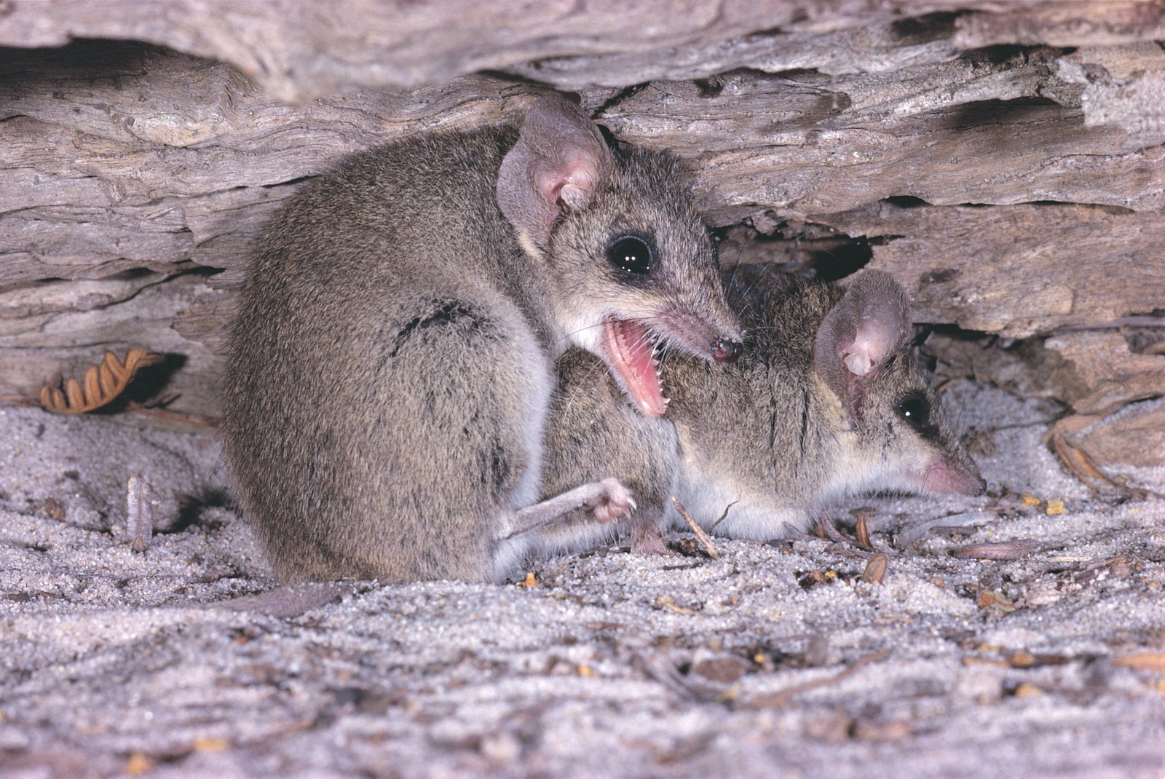

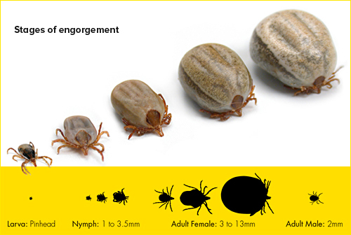

**Figure 1**. Image of male and female *S. murina* (A). Stages of engourgement for Ixodes spp. that are can be fund on *S. murina* (B).

Parasitism can negatively affect host health and impose energetic costs, potentially influencing traits critical for survival and reproduction. In particular, ticks can impair performance traits such as sprint speed—vital for escaping predators—and reduce body condition, an important indicator of overall health. Larger individuals may be more susceptible to parasite attachment due to increased surface area, and male dunnarts may experience different exposure rates or immune responses due to sex-specific hormones. Because longer limbs or bodies can mechanically enhance stride length and running speed, we record traits like body length and hindlimb length to account for size-based variation in locomotor ability.

This study explores how tick parasitism varies between sexes, whether body size predicts tick load, and whether tick burden impairs locomotor ability or body condition in wild-caught dunnarts.

**METHODS:**

Data were collected from Common Dunnarts captured in Grampians National Park, Victoria, Australia in 2024. Animals were caught using pitfall traps and assessed for morphological and parasitism data. For each individual, body length (mm), body mass (g), and hindlimb length were recorded (g). Sex was determined based on external morphology. Tick presence and tick counts were recorded in the field.

Locomotor performance was measured within 24 hours of capture. Dunnarts were encouraged to run on a standardised 2.4-meter track, with trials filmed for speed analysis. Maximum sprint speed was calculated as the fastest 25 cm interval, and 2-meter speed was defined as the fastest continuous run across the track. Only uninterrupted runs were included. Body condition indices (BCI) were calculated using the residuals from a regression of mass on body length, providing an estimate of individual health independent of size.

**DATASET DESCRIPTION:**

The dataset contains measurements and observations from captured Common Dunnarts. It includes variables on:

* ID: Individual animal identifier
* Sex: Male (M) or Female (F)
* Body_length: Total body length in mm
* Mass: Body mass in grams
* Hindlimb_length: Length of the hindlimb in mm
* Ticks_present: Presence (1) or absence (0) of ticks
* Tick_count: Number of ticks on each individual
* Max_sprint_speed: Maximum sprint speed (m/s)
* Max_2m_speed: Maximum speed over 2 meters (m/s)

**YOUR OBJECTIVE:**

Using the provided dataset (*Ticks_data_final.csv*) and its accompanying metadata file (*Meta_Data_ColumnNames.csv*), students will address the following three specific questions. Each question corresponds to creating one or more plots. Students may need to transform or subset the original data to address these questions clearly. Students should aim to clearly visualise relationships through appropriate graphs and conduct statistical analyses to answer these questions.

Question 1: Do male and female Common Dunnarts differ in tick prevalence, and is tick infection more likely in larger individuals?

Question 2: Does tick infestation negatively affect locomotor performance (maximum sprint speed and 2-meter run speed) in Common Dunnarts?

Question 3: How does tick presence influence the overall body condition (BCI) of Common Dunnarts?

Students should aim to clearly visualise relationships through appropriate graphs to answer these questions.